Font families

font-family: 'Crete Round', serif;



font-family: 'Lato', sans-serif;



font-family: 'Raleway', sans-serif;



colors

https://color.adobe.com/Eshan-Cpwd-web-color-theme-11038834/

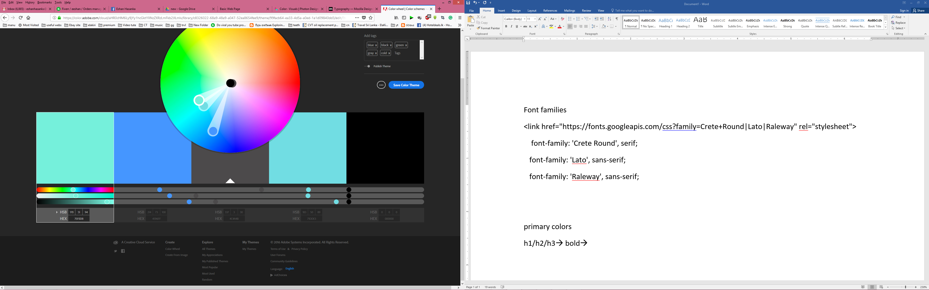

#75F0DB /#4596FF / #4C4A4B / #71DDE3 / #000000

**Background color**

#71DDE3 

**Primary colors**

h1/h2/h3

font/font size - Crete Round, serif;

#4C4A4B 

Pragraphs

font/font size-

color-

anchors

normal color

hover color

**button types**

normal

color

font

hover

color

font